Feature1: Product Comparison
Product comparison feature allows the ShoeStore users to compare the features and price of more than one product. This will help the user to have a detailed analysis of the products based on the description, price and thumbnail. The backend organization of this feature is discussed below:
- Table Structure
When the user is in the product description page, besides of Add to Cart button there is an Add to Compare button. On clicking that, the current product will be added to the comparison list along with the user’s ip address. This is a hidden data from the end user. The data are stored into the back end MSSQL in the following table format
Table: COMPARE_LOG
Column | Properties | Description
USER_UID | - VARCHAR(100)  - NOT NULL | This column holds the ip address of the user who is adding the product for comparison
PRODUCT_ID | - INT | This column hold the unique id of the product added to comparison list

When the user adds multiple products to the comparison list, a row is inserted to COMPARE_LOG table. So there can be multiple rows for the same USER_UID. That is the reason why USER_UID is not a primary key. When the user goes to product comparison page, all the product_id logged towards the user_ip is retrieved and displayed.
- Stored Procedures
The following stored procedures are used to perform different functionalities associated with product comparison feature
Stored Procedure | Parameter |  | Description
ADDTOCOMPARE | USER_IP | VARCHAR(100) | This store produced is utilized to insert data such as user ip address and product id to the COMPARE_LOG table.
ADDTOCOMPARE | PRODUCT_ID | INT
REMOVE_COMPARISON | USER_IP | VARCHAR(100) | This procedure will be responsible for removing single product at a time from the COMPARE_LOG table.
REMOVE_COMPARISON | PRODUCT_ID | INT
REMOVE_ALL_COMPARISON | USER_IP | VARCHAR(100) | This stored procedure is responsible to flush all the product id’s logged to the COMPARE_LOG table for the user. This clears the product comparison list.
COMPAREPRODUCTS | USER_IP | VARCHAR(100) | This stored procedure retrieves the list of product along with necessary information for comparison for a particular user. The fetching is based on the current user’s ip address. Due to space constraint in the user interface, the top 5 products are retrieved.s

- Functionality and Screenshot
  - Add to compare
Click on Add to Compare button in the product details page.
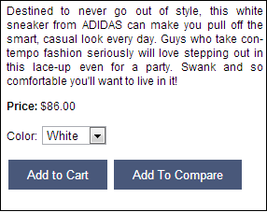
  - Confirmation
User will get a confirmation, that the product has been added to Comparison list. Add multiple products to the comparison list.
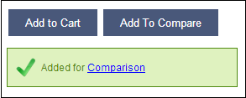
  - Click on Comparison link
User will be re-directed to the product comparison page
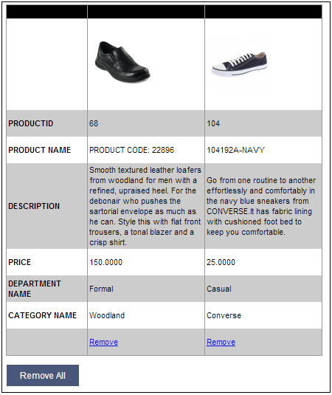
Remove Link triggers the REMOVE_COMAPRISON stored procedure and removes the product_id from the COMPARE_LOG table for the current user.
Remove All link triggers the REMOVE_ALL_COMPARISON stored procedure which removes all the product_ids linked to the current user’s ip address.

